Introducing the Practice of Asymmetrical Regauging to Increase the Coefficient of Performance of Electromechanical Systems

M. Walters, M.R. Zolgahdri, A. Ahmidouch*, A. Homaifar

Center for Power Electronics Systems
Department of Electrical and Computer Engineering
*Department of Physics
North Carolina A & T State University
Greensboro, NC 27411 USA

Abstract--This paper introduces asymmetrical regauging theory as the origin of the increase in the coefficient of performance of a specially designed electric motor. The coefficient of performance terminology, a review of gauge theory, and an examination of discarding the Lorentz condition to achieve asymmetrical regauging are presented. Finally, building a “Wankel” motor to verify this theory is proposed.
- introduction
European theoretical electrodynamicists have, in the last few years, published voluminous papers[1-3]in the field of electromagnetics. In particular [1], offers one possible explanation to an electromagnetic process referred to in one recent permanent magnet (PM) motor patent [4] as “asymmetrical regauging” (ASR). Using this process, these specially designed patented PM motors claim to capture and use environmental energy as an additional energy source.
This paper simplifies and explains these theories and introduces a simple machine that may be built to investigate the above claims. First, the term coefficient of performance (COP) is introduced to adequately describe the energy transfer of these new motors. The physics behind the ASR process will then be examined by reviewing gauge theory and the Lorentz gauge, and introducing the asymmetrical regauging terminology. Finally, this paper will consider the proposed design of a “Wankel” motor.

coefficient of performance
The energy transfer of electrical machinery is generally described using the term “efficiency”. Efficiency is defined as the output power divided by the total input power from all sources. The underlying assumption when defining the energy of any system is that all the energy input is from an identifiable and measurable energy source(s). In an ideal system, with no losses, the upper limit for efficiency would reach one. The equation for efficiency is normally stated [5] as

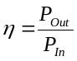. (1)
Coefficient of performance is a broader energy transfer term that defines the measure of output power divided by the operator’s input power. COP is used to describe any machinery that has additional energy input from the environment. For example, COP is commonly used to describe the energy exchange of heat pumps[6] or solar collectors. Unlike the term “efficiency”, the COP defined in (2) can be greater than one. See Fig. 1 for the energy flow diagram. COP is usually greater than efficiency and will be equal to the efficiency if the environmental energy input is zero.
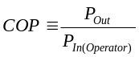 ₍₂₎

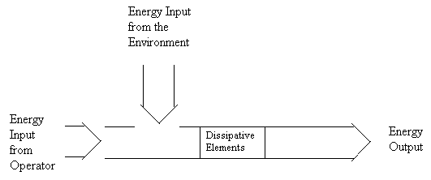
Fig. 1. Energy flow for machines described by COP.
- review of the lorentz gauge
To understand how environmental energy may be utilized in a motor, to theoretically gain a COP > η, a review of the Lorentz gauge is first presented. The equations used in standard practice to design motors are derived from Maxwell’s equations. It has been accepted practice, to apply the Lorentz gauge to these equations to make them simpler. In abbreviated steps, we start with Maxwell’s equations [7]:

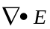=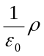 (Gauss’s law) (3)

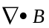=0 (4)

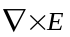= –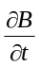 (Faraday’s law) (5)

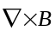=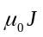+ 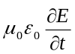 (Ampere’s law & displacement current) (6)
All the information in Maxwell’s four equations can be reduced to the following two equations [7]:

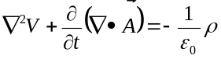 (7)

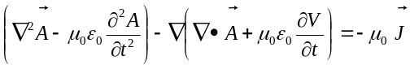 (8)

The Lorentz gauge is then applied to reduce the complexity of these two equations. Mathematically, applying any gauge, is represented by (9,10) where gamma is an arbitrary, differentiable scalar function called the gauge function [8] .
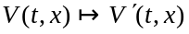=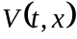 –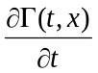 (9)

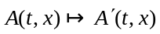= 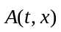+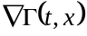 (10)
To specifically apply the Lorentz gauge, the “Lorentz Condition” is imposed by choosing a set of potentials (A, V) such that

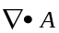 =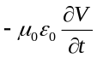. (11)

Using the Lorentz gauge, (7) can be reduced to (11,12) [8]. Equations (11,12) are the ones on which all the equations for motor design are currently based [9]. Since the magnetic vector field and the voltage scalar field are both changed at the same time, this is an example of what can be referred to as symmetrical gauging.
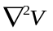 – 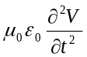= – (12)

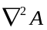–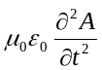= –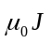 (13)
Notice that (13) is (8) with the middle term, (14), eliminated.

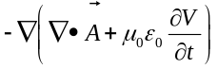 (14)

Asymmetrical regauging
Invoking the Lorentz condition in classical electromagnetics discards the vacuum polarization component that has been shown phenomenologically, by Lehnert and Roy [10], to exist. Equation (15) states this mathematically.
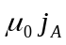 (15)
where 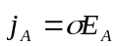. (16)
The current density (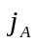) comes from the vacuum in a way that is analogous to Maxwell’s displacement current. Asymmetrical regauging is the equivalent of discarding the Lorentz condition so that the effects of the vacuum current density may be included. Furthermore, ASR is defined as any process that changes the potential energy of a system and also produces a net force in the process [1].
Understanding the vacuum and its polarization are essential steps to utilizing energy from the environment. According to Noble Laureate T.D. Lee, quantum physicists define the vacuum state as the lowest energy state of the system [11]. Hence, the vacuum is considered to be the worst case model of the environment. Maxwell’s equations must be modified, in the vacuum, since and vanish. For the vacuum, the classical equations for Gauss’s law and the Ampere-Maxwell law are the two equations that must be revised. Refer to equations (3-6).
= 0 (17)
= (18)
In [1, 10], the authors show that if the vacuum current density factor is included, the Ampere-Maxwell law equation changes to
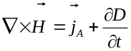 (19)
where 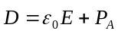 and 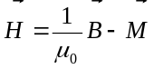. (20)
This leads to the result that
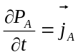. (21)
Hence, discarding the Lorentz condition in classical electrodynamics leads to new equations that include the effect of the vacuum polarization. This is a first step to showing physically how it may be possible to use the vacuum as an energy source.
It has already been shown in quantum electrodynamics (QED) that the vacuum behaves like a dielectric [12]. The vacuum sprouts positron-electron pairs as shown in the Feynman diagram in Fig. 2. Except that it has a positive charge equal to the electron’s negative charge, a positron is an elementary particle that has the same mass and characteristics as an electron [13]. In the Feynman diagram, only the particles that enter or leave the diagram are “real” or observable. Without changing the process, the internal particles cannot be observed. Hence, they are deemed “virtual” particles. The internal particles represent the physical “mechanism” involved [12].
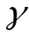Fig. 2. Feynman diagram of vacuum polarization [9].

- future work
It has been shown that by discarding the Lorentz gauge, the Ampere-Maxwell law equation evolves to include the current density of the vacuum. The task remains to delve deeper into this theory and to verify it by applying it to a magnetic motor.
The predecessor to this patented motor[4] appears to be a motor previously called the “Wankel motor” [14]. Future work is planned to study the Wankel motor to ascertain the exact mechanism involved that allows this motor to exchange energy with the vacuum. First, this work will be to simulate the electromagnetic fields using Magsoft’s Flux 2-D. Using the theory introduced, then the work will be to design, build and test a brushless DC motor and drive. Whether the asymmetrical regauging effect can be observed, is to be determined.
The model proposed will be a prototype based on the “Wankel Motor”. Developed by the Japanese, the Wankel Motor is named after its similarity to the Mazda rotary engine developed by Fritz Wankel. The first known reference to this motor was by [14]. See Fig. 3 for the conceptual diagram of the Wankel motor.
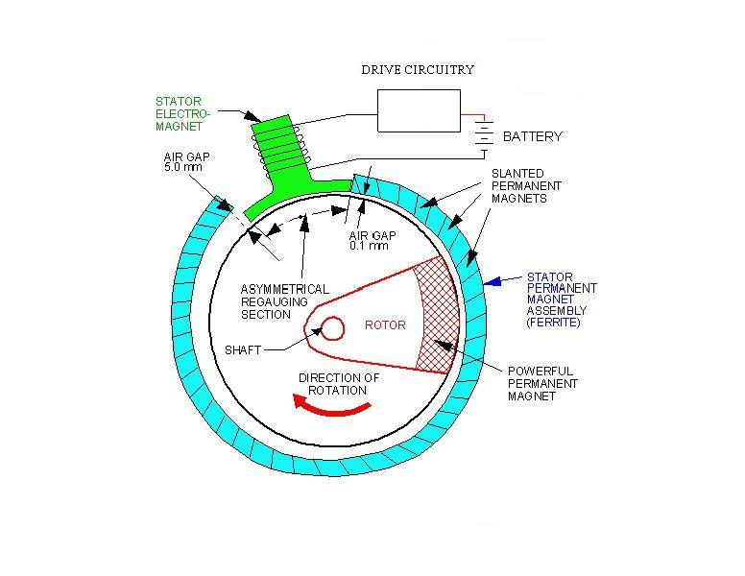
Fig. 3. Conceptual diagram of the Wankel Motor [14].
The stator portion consists of permanent magnets wrapped into a partial spiral configuration while the circular rotor consists of a singular circular magnet and a counter weight (not shown). The rotor and stator magnets are positioned so that their polarities give rise to a repulsive force. For instance, the stator magnetic north pole faces the rotor magnetic north pole, thus, the north pole of the rotor is in a nonlinear magnetic field and experiences a clockwise force and acceleration from the point of the smallest air gap to the point of the largest air gap (Gaps of .1 mm and .5 mm are given for reference) [15].
The purpose for this spiral arrangement is to confine the back EMF to a single portion of the motor. As the rotor enters the spiral gap, it must be suddenly gauged asymmetrically to a magnetostatic scalar potential equal to or greater than the potential at the other end of the spiral gap where the magnetic gap is smallest [15].
This sudden increase in the magnetostatic potential is accomplished in the following manner. During the time the stator is rotating, a trickle current is maintained, at a small voltage, through the coil of the electromagnet. Just as the rotor enters the spiral gap, a sensor indicates its position and causes the circuit to abruptly open. This creates a high dv/dt in the coil of the electromagnet. Due to the Lenz law effect, a sharp di/dt is created, in the coil, which produces a sharp and sudden increase in the magnetostatic potential called the multi-valued potential.
The second law of thermodynamics has known and accepted violations where negative entropy is produced temporarily, including the statistical fluctuations of an equilibrium many-particle system [16-18]. A major but still little-understood violation can also be provided by a sharp gradient [19]. This accomplishes the previously discussed ASR process that changes the potential energy of the system and produces a net force that kicks the stator magnet across the gap.

conclusion
It has been shown that by discarding the Lorentz gauge, the Ampere-Maxwell law equation evolves to include the current density of the vacuum. The physics behind one possible explanation for this phenomenon is presented.
The physics is explained by first considering how the Lorentz gauge is used to give us the design equations used today. The Lorentz gauge is then discarded to show how the current density of the vacuum may be included in the Maxwell-Ampere equation. The term asymmetrical regauging is defined for this procedure and the particle physics explaining the vacuum polarity is mentioned.
The Wankel motor has been introduced as a possible mechanism to demonstrate this ASR process. A preliminary explanation of the physics behind the motor design has been given.

acknowledgement
Helpful discussions with T. E. Bearden, CTEC, Inc. are acknowledged.

Nomenclature
Cross Product
Dot Product
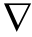 Vector operator “del”=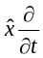+ 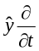+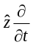.
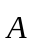 Magnetic vector potential
 Magnetic field
Electron
Permittivity of free space
 Electric field strength
Photon
Electric current density (volume)
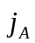 Vacuum current density
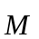 Magnetization
Permeability of free space
Efficiency
Positron
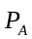 Classical vacuum polarization
(Dipole moment per unit volume)
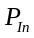 Electrical Power Input
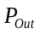 Mechanical Power Output
Charge density
Vacuum conductivity
 Electric potential
references
[1] P. K. Anastasovski, T. E. Bearden, C. Ciubotariu, W. T. Coffey, L. B. Crowell, G. J. Evans, M. W. Evans, R. Flower, F. Jeffers, A. Labounsky, B. Lehnert, M. Meszaros, P. Molnar, J. Vigier, and S. Roy, "Classical electrodynamics without the Lorentz condition: extracting energy from the vacuum," Physica Scripta, vol. 61, pp. 513, 1999.
[2] M. W. Evans and T. E. Bearden, "The most general form of the vector potential in electrodynamics," Foundations of Physics Letters, vol. 15, pp. 245-261, 2002.
[3] B. Lehnert, S. Roy, and A. Deb, "An extended electromagnetic theory," APERION, vol. 7, pp. 53-58, 2000.
[4] J. Bedini, "Device and Method of a Back EMF Permanent Electromagnetic Motor Generator." US: Bedini Technology, Inc., 2002.
[5] A. Trzynadlowski, Introduction to Modern Power Electronics. New York: John Wiley & Sons. Inc., 1998.
[6] K. Annamalai and I. Puri, Advanced Thermodynamics Engineering. New York: CRC Press, 2002.
[7] D. Griffiths, Introduction to Electrodynamics. New York: Prentice-Hall, 1999.
[8] B. Thide, Electromagnetic Field Theory. Uppsala: Upsilon Books, 2004.
[9] C. Trowbridge, Three Dimensional Analysis. Boca Raton: CRC Press LLC, 2000.
[10] B. Lehnert and S. Roy, Extended Electromagnetic Theory. Singapore: World Scientific, 1998.
[11] T. D. Lee, Particle Physics and Introduction to Field Theory. New York: Harwood Academic Publishers, 1981.
[12] D. Griffiths, Introduction to Elementary Particles. New York: John Wiley & Sons, Inc., 1987.
[13] S. Parker, "Dictionary of Physics," l, Ed., 2nd ed. New York: McGraw-Hill, 1997, pp. 498.
[14] D. Scott, "Magnetic "Wankel" for electric cars," in Popular Science, 1979, pp. 80-81.
[15] T. E. Bearden, Energy from the Vacuum: Concepts and Principles. Santa Barbara: Cheniere Press, 2002.
[16] D. J. Evans and D. J. Searles, "Equilibrium microstates which generate second law violating steady states," Physical Review E., vol. 50, pp. 1645-1648, 1994.
[17] G. Crooks, "Entropy production fluctuation theorem and the nonequilibrium work relation for free energy differences," Physical Review E., vol. 60, pp. 2721-2726, 1999.
[18] G. Wang, E. Sevick, E. Mittag, D. Searles, and D. Evans, "Experimental demonstration of violations of the second law of thermodynamics for small systems and short time scales," Physical Review Letters, vol. 89, pp. 050601, 2002.
[19] D. Kondepudi and I. Prigogine, Modern Thermodynamics. New York: John Wiley & Sons, Inc., 1999.

This work was supported in part by the ERC Program of the National Science Foundation under Award Number EEC-9731677.

